November 2026 Newsletter
Robert Kemp Turner Elementary School
141 Circassion Drive, Dartmouth, NS B2W 4N7
902-464-5205, Safe Arrival 1-833-582-6940
We’re Rockets Soaring to Success!
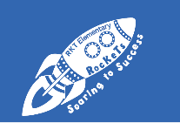

Principal’s Message
Dear Family,

In a blink, not 1 but 2 months of school have already gone by! October was another fast paced and exciting month. A special note of thanks to students and teachers for the wonderful work being done in each classroom. Our students are busy learning new math concepts, strengthening their class social communities, and encountering rich language and story development. Some students have even stepped back in time with appreciation for those who have come before them!
As the crisp autumn air settles in, please remember to send your children to school dressed for the changing weather with warm coats, hats, and gloves so they stay cozy during outdoor play. Please see the HRCE Planning for Inclement Weather section in this months newsletter for more information. Speaking of wild weather—the strong autumn wind blew over our school sign! Sturdier posts have been installed, and we look forward to having the sign back in use as soon as possible.
Thank you for making our recent School Assembly, Family Dance and School Spirit Week such wonderful successes! It was heartwarming to see our students showcase their bright smiles, fall enthusiasm, creativity and school pride. November brings so many great opportunities for our students to build new friendships, embark on exciting learning adventures, and lend a helping hand to classmates who might be going through a tough time.
The vast majority of our students do a fantastic job keeping their bodies safe while at school. However, a few children still need reminders—both at school and at home—about playground safety. Parents, please talk with your child about the importance of gentle play, reminding them our hands and feet must be kept to ourselves unless we are using them to help or include others. When every family has this chat at home, it helps all students come to better understand the shared safety expectations while they are at school.
As always, please don’t hesitate to reach out when you have need,
Regan
Important School Information

School Advisory Council
Looking for a way to get involved and shape your child’s school experience?
Join the RKT School Advisory Council (SAC)! We are looking for parent/guardian and community members to help support student success and share ideas on school projects and decisions.
- No experience needed—we welcome diverse perspectives and voices!
- Next Meeting: Monday, November 16th, 5:00 PM – 6:00 PM (School Library)
If you are interested but the meeting time doesn't work for you, let us know and we will do our best to accommodate your schedule.
Please contact Ms Clancey (902-464-5205 ext 6741001) to join or express interest!

Home and School
Thank you to our H&S committee members for hosting the fun Costume Dance for our families! Thank you for the families and staff who so creatively committed to the excitement; the costumes were fantastic!
We’d love to have you join our Home & School Committee! Whether you have a little time to give or a lot, every bit makes a big difference—after all, many hands and minds make lighter (and more fun!) work. If you're interested in volunteering with us, reach out and let us know! We’d be delighted to connect you with one of our committee members.

Safe Arrival
On days when your child will be late or absent, please let us know. Our Safe Arrival number is
1-833-582-6940. The only option to select is Absent with Notification. Select this for an Absence or late arrival. When your child arrives late, the office will update their attendance. Students must check in at the office when arriving late.

Allergy Alerts / Medication
We have numerous students and staff with severe allergies to food and scents. Please refrain
from wearing scents when in our school and be diligent about the food items your child brings to school. Due to serious allergies, nuts, nut products and sesame cannot be sent to school.

If your child requires prescription medication to be given during school hours, an “Administration of Medication” form must be filled out and on file in the main office. All medicine is kept secured and distributed from the main office. Medications are required to be in the original container and clearly labelled for your child.

If your child has a severe or life-threatening allergy or medical condition, please contact the office directly at 902-464-5205 so we can ensure a Plan of Care is in place for your child.

Communication
We continue to welcome new families to our school. If you need any assistance regarding communication between home and school, please contact the school office.

School Community Information
The Kraft Dinner (Pasta) Donations continue to pour in; WOW! We will collect until Nov 20th with a wrap up special celebration the following week. Thank you, students and families, for your generosity.
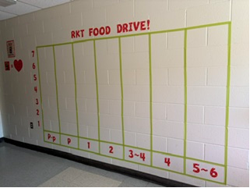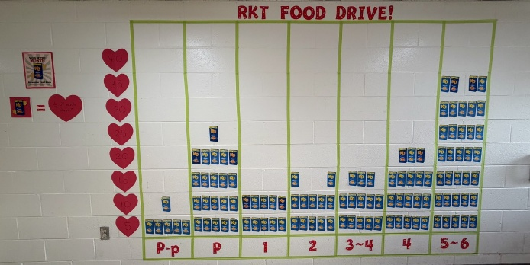
In the beginning, we were here. As of Oct 30, where we are now!

Each box on our graph equals ¼ of each class.
That’s a lot of food for other kids and their families!

Thoughts From Our Students
You’re so nice!
Who’s getting the ball, so we can play?
You’re OUT!
That’s okay, I’ll help you.

HRCE Information for Families
 Planning for Inclement Weather
It is HRCE’s goal to communicate any changes to the regular operations of schools and/or busses as close to 6:00 a.m. as possible. A 6:00 a.m. announcement could be:
- All schools are delayed in opening by two hours and bus pickups are delayed by two hours; or
- All schools are open, but some or all busses are not operating for the day; or
- Some schools (either individually or by family) are closed for the day; or
- All schools are closed for the day.

If weather deteriorates, or is forecasted to worsen throughout the morning, an 11:00 a.m. announcement could be:
- Bussed students will be picked up two hours earlier than their regular dismissal time; and
- Non-bussed students will be dismissed at their regularly scheduled lunch hour.
How will I find out?
- By email to the addresses in PowerSchool
- By text message, if you have opted-in. If you aren’t sure if you have opted-in, text Y to the following number: 978338
- On the HRCE website
- On Instagram
It’s important to always have a plan in place for childcare in the event of any cancellation. Please remember: As a parent or guardian you always have the choice of whether or not to send your child to school.
For more information on how HRCE manages during inclement weather, visit hrce.ca/families/cancellations.

 Indigenous Veterans Day
On November 8, we recognize Indigenous Veterans Day and honour the First Nations, Inuit and Métis people who have served and continue to serve in the Canadian Armed Forces. Indigenous veterans have made significant contributions to Canada’s military history, serving with courage and dedication while often facing discrimination and barriers to recognition when they returned home.
This day is an opportunity to learn about their stories, recognize their sacrifices and reflect on the importance of ensuring their contributions are remembered and honoured.

We encourage families to take a moment to learn about Indigenous veterans and share their stories with the next generation. Learn more here.

 November 11 is Remembrance Day
Each year on November 11, people across Canada pause at the 11th hour to remember. The poppy we wear, the silence we observe and the stories we share are ways of keeping the memory of those who served, those who never returned home, and the lasting impact of war alive for future generations.
In our schools, Remembrance Day offers students an opportunity to explore the meaning behind these traditions and consider what remembrance looks like today. As we honour the past, we also reflect on the importance of peace, kindness and understanding in our own communities.

We invite families to join Canadians across the country in taking a moment to remember.

 Happy Diwali
Diwali, also known as the Festival of Lights, is celebrated by millions of people around the world, including Hindus, Sikhs, Jains and some Buddhists. The celebration carries different meanings across traditions, but often centres on themes of light overcoming darkness, good overcoming evil, and hope, renewal and new beginnings.
Celebrations may include lighting diyas (small oil lamps), decorating homes, sharing special foods, exchanging gifts and gathering with family and friends. Diwali is an opportunity to learn about the diverse traditions and cultures represented in our school communities and to celebrate the many ways people find meaning, connection and joy.

Key Dates for Diwali 2026 in Nova Scotia
- Nov 5 (Wednesday): Gowatsa Dwadashi (Day 1)
- Nov 6 (Thursday): Dhanteras / Lakshmi Kuber (Day 2)
- Nov 7 (Friday): Kali Chaudas / Abhyang Snan (Day 3)
- Nov 8 (Sunday): Diwali / Lakshmi Puja (Main Day)
- Nov 9 (Monday): Govardhan Puja / Annakut (Day 4)
- Nov 10 (Tuesday): Bhai Dooj (Day 5)
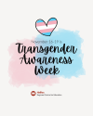 November 13-19 is Transgender Awareness Week
Transgender Awareness Week is an opportunity to reflect on how kindness, inclusivity and understanding help create welcoming school communities where everyone feels they belong. Taking time to learn about experiences different from our own, listening with an open mind and treating others with respect can make a meaningful difference in someone’s day and sense of belonging.
Families can help reinforce these values by encouraging children to lead with kindness, embrace differences and recognize that everyone deserves to be treated with dignity and compassion. Together, we can help create school communities where every student feels welcome, valued and supported.

 Free screening of “Your Attention Please”
Join Unplugged Canada’s Nova Scotia Chapter for a FREE screening of the documentary "Your Attention Please" on December 3, from 6 p.m. to 8 p.m. in the White Spruce Room at Keshen Goodman Library.

Parents, caregivers and educators are invited to watch this thought-provoking documentary about the impact of technology on our attention and come together for a discussion on how we navigate this with youth in our own community. Please register in advance as tickets are limited.
Event: FREE screening of Your Attention Please
Date: December 3, 2026
Time: 6 p.m. to 8 p.m.
Location: White Spruce Room, Keshen Goodman Library
Cost: FREE
Register: https://yourattentionpleaseNS.eventbrite.ca

Important Dates
Nov 4: Picture Retakes (for those wanting a retake or those previously absent)
Nov 8: Indigenous Veterans Day
Nov 9: Fluoride Treatment Day 1 of 2
Nov 10: Remembrance Day Ceremony – 10:30. We welcome our current and previously serving military family members to join us in the gym during this time.
Nov 11: Remembrance Day – Schools closed
Nov 13-19: Transgender Awareness Week
Nov 16: School Advisory Committee (SAC) Meeting 5:00-6:00pm
Nov 20: Assessment & Evaluation Day (Term 1 Ends) – No school for RKT students
Nov 26: Reports sent home
Nov 30: School Wide Assembly
Dec 4: Student Progress Conferences
Dec 8: Winter Concert (storm date Dec 10)
Dec 18: Last day of school for students before holiday break

Have an idea or announcement for the Monthly School Newsletter? Send it our way! Let us know what you’d like to see or share, and we’ll do our best to include it.

