Robert Kemp Turner Elementary School Newsletter
May 2026
141 Circassion Drive, Dartmouth, NS B2W 4N7 902-464-5205 Safe Arrival 1-833-582-6940

We’re Rockets Soaring to Success!


Dear Family,

It seems April came and went as fast as the weather can change in Nova Scotia. Despite the fast pace, there was much learning, fun and growth happening at RKT over the last month. The month began with great conversations with families and students about their successes and areas to continue to develop. Thank you for joining us to celebrate your child! This month we also completed another successful fire safety drill, continued building relationships with our Big Bears in Muinjij Program, and fostered connections with local artists.

Daily we attend to our school wide Expectations Matrix as we remind, refine and revise our efforts in how we talk and act with each other. We put our ‘WITS’ (walk away, ignore, talk it out, seek help) strategies to great use as we focused on how ‘We Are Safe’ throughout our day in all locations and spaces. Worthy of celebration is how we refined our outside play structures and interactions to navigate around the playground conditions and relational dynamics. Our students demonstrate incredible problem solving and creative thinking when given the chance and challenge!

Take a read below of all the things we can celebrate during the month of May. May is Asian Heritage Month, Canadian Jewish Heritage Month, Polish Heritage Month, and Speech and Hearing Month. Within the month some key days to note include May 5 - Red Dress Day, May 10-16 - Education Week, May 15 - Black Excellence Day, May 17 - International Day against Homophobia, Transphobia and Biphobia, and May 18 - Victoria Day which is a holiday so there will be no school on this day. The month’s end is the beginning of Access Awareness Week which extends through June 6. May is shaping up to be a busy one!

Wishing you a marvelous month,
Regan

A Peek at Some RKT Awesome April Activities

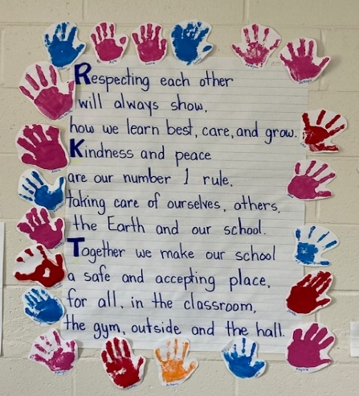
A display of our School Vision. Our grade 1/2 class is often overheard reciting these powerful words to begin their day together.

 We celebrated Earth Day in many ways including some school yard clean up. Our grade 6 class created this beautiful piece of art on display in our upstairs hallway.

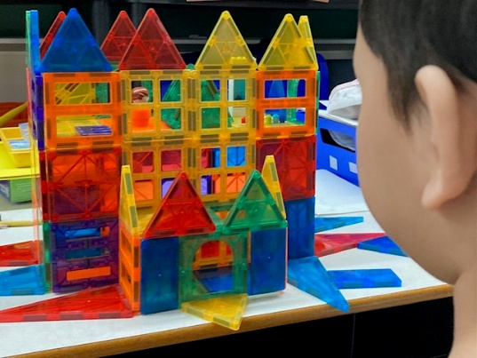
A few quiet moments to ourselves produce some amazingly artistic and scientific designs!

SCHOOL INFORMATION
Parking Lot Safety
We have designated ENTRY and EXIT routes. Please refer to the map below as an easy visual of the area referenced in the procedures below. It is important for everyone’s safety to share our parking lot procedures with anyone who drops off/picks up your child(ren). Please be mindful, especially on rainy and foggy days when visibility can be challenging, children/families are moving along the sidewalk which opens into our parking and yard areas. We greatly appreciate YOU who appropriately use the Drop & Go Lane. This has greatly eased the traffic congestion experienced earlier in the year. In aim of continuous safety improvement, we ask drivers to use a designated parking spot rather than parking along the edge of the Entry way in front of the large garbage bins (right side along treed area in picture below). If there are no spots available in the front of the school, you may park in the ‘staff parking’/overflow area to the right side of the school, please pull up close to the school wall).

No Cars Permitted – Class Line Up Area

Parking Lot Use Procedures
- Enter the driveway closest to Glenalva Court.
- Remain in the Drop & Go near the bottom of the parking lot (below car spaces) and pull up closest to the Exit before saying goodbye to your child. This allows multiple cars to be in the drop off lane at once and helps prevent blocking the crosswalk and having cars stopped half-way and waiting on the road.
- Exit the driveway directly opposite the school’s main doors.
- The gravel section is to always remain free of cars when students are present

Home and School News
A big THANK YOU to our Home & School Committee volunteers who surprised our students and staff with a Pizza Lunch on April 30th. It was much appreciated and enjoyed; YUM YUM! Our next meeting will be May 6th from 5:30-6:30 if you are able to join us. We will be working on our Spring Fair preparations among other planning for next year.

SAC News
Our SAC meeting information can be found on our school website. If your interested to join our committee, please don’t hesitate to let the office know. Our next meeting will be on May 11th from 5:00-6:00 pm.

Food Donations for Encounter Food Bank
When you are at school next, please read the Thank You Card from Encounter Food Bank posted on our Heart Board in the lobby area. Suggested donation items for the month for May are displayed in the poster below. Thank you for helping families in need.

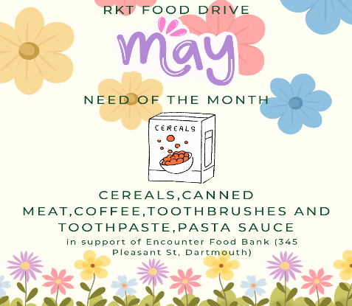

SCHOOL BASED REMINDERS
Safe Arrival / Student Absences
Our Safe Arrival number is 1-833-582-6940. Please report your child’s absence. If your child is going to be late, please report them as absent and the office will update it when they arrive. Students who arrive after their class line has entered the building must come to the office to check in. Pre-Primary students are to be dropped off at the Pre-Primary door. Please ring the bell on the wall near the PP lineup door and staff will come out to meet you.

Allergy Alerts / Medication
If your child has a severe medical condition and/or requires prescription medication to be taken while at school, please contact the main office for the necessary documentation and procedural information.

Head Lice Reminders
Please make checking for the presence of nits and/or lice part of your family routines. The cold weather does not keep them away.

Water Bottles
Please remember to send a water bottle to school with your child. We have filling stations for them to refill their bottle throughout the day.

Halifax Regional Centre for Education (HRCE) INFORMATION

Unplugged Webinar on Smartphones, Social Media and More

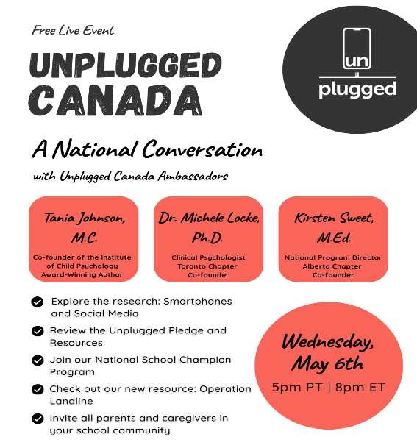

Unplugged Canada is hosting a LIVE webinar on May 6 every parent and caregiver needs to hear. We're talking smartphones, social media, the research — and most importantly, what we can do about it.
Hosted by Kirsten Sweet, educator and National Program Director with Unplugged Canada with Tania Johnson, Co-founder of the Institute of Child Psychology and Dr. Michele Locke, Clinical Psychologist, learn about the impact of smartphones and social media on youth and how the Unplugged Canada Pledge and our resources can spark meaningful conversations in your home, school, and community.
We'll also introduce two new initiatives: the National School Champion Program and Operation Landline — a summer campaign helping families delay smartphones and reconnect in simpler, more intentional ways.
Come ready to learn, connect, and be part of the movement. Register here.

May 15 is Black Excellence Day


Black Excellence Day 2026 in Nova Scotia is an opportunity for schools to reflect on the learning and exploration of Black people and culture over the past year. It recognizes, celebrates, and supports learning from the achievements, contributions, and leadership of Black individuals and communities. More than a single-day celebration, Black Excellence is the recognition of meaningful steps toward strengthening inclusive learning environments where all students see themselves reflected in curriculum materials, through the stories we tell and the histories we honour.
The purpose of celebrating Black Excellence in our schools and classrooms is to affirm student's identities, build confidence, and inspire futures by highlighting role Black people have made in education, science, arts, leadership, and community advocacy. It reflects and celebrates thoughtful conversations in schools about equity, representation, and the ongoing work to remove systemic barriers.
This moment of reflection also invites educators and school communities to consider how Black Excellence is represented within their own classrooms and learning spaces. For some, this may affirm intentional work already underway; for others, it may serve as an opportunity to begin or deepen this practice. Black Excellence Day reminds us that this work is ongoing, and that there is always time to plan, reflect, and be deliberate in ensuring all students see themselves meaningfully reflected in our schools.
We welcome everyone to wear a black shirt, if you’re able, on May 15 to show your support for Black Excellence Day!

Screen Free Summer: Digital Diet Guidance
As summer approaches, many families are thinking about screen time. This article introduces the idea of a “digital diet,” encouraging a focus on the quality and purpose of screen use rather than just limiting it. It offers practical ways to help children build healthier, more balanced habits with technology. Read more here.

Access Awareness Week - May 31 to June 6
Access Awareness Week in Nova Scotia, taking place May 31–June 6, 2026, is an opportunity to recognize the importance of accessibility, inclusion, and the leadership of people with disabilities. This year’s theme, “Disability Justice: Stronger Together, First Voice Leading Change for Collective Action,” emphasizes the importance of centering lived experience and working collaboratively to create meaningful, lasting change.
In schools, this week is a powerful reminder that inclusion is everyone’s responsibility. Classrooms are where understanding begins — through learning, conversation, and action. By listening to diverse voices, removing barriers, and fostering accessible learning environments, educators and students help build school communities where all learners feel valued and supported.

UPCOMING IMPORTANT DATES

MAY
May 4: Grade 6 Band Night – CHDH arrive 5:30 for 6:00 concert
May 5: Red Dress Day
May 6: Home & School Meeting 5:30-6:30
May 10-16: is Education Week
May 11-15: Fire Drill this week
May 11: SAC Meeting 5:00-6:00
May 12, 14, 19, 20: Grade 3 Provincial Assessments
May 15: Black Excellence Day – Wear Black Shirt
May 17: International Day against Homophobia, Transphobia and Biphobia
May 18: Victoria Day Holiday – Schools Closed
May 21: Spring Concert – 2 viewings (afternoon 1-2 and evening 6-7)
May 26: Track & Field Meet (participating grade 4,5,6 students (family transportation required)
May 31 to June 6: Access Awareness Week

JUNE
June 2: Grade 6 visit to Sir Robert Borden (rain date – June 3)
June 8: SuperNova – Science Based Learning Presentations to classes
June 25: Grade 6 Closing
June 29: Assessment and Evaluation Day
June 30: Last day of school for students and staff

