Robert Kemp Turner Elementary School Newsletter
April 2026
141 Circassion Drive, Dartmouth, NS B2W 4N7 902-464-5205 Safe Arrival 1-833-582-6940

We’re Rockets Soaring to Success!

Dear Family,

With a few blinks of the eye Spring has sprung! I hope you enjoy seeing some of our March moments. We certainly packed a lot into only 16 days this past month!

Autism Awareness Day is on April 2. This year’s theme, “Autism and Humanity – Every Life Has Value,” highlights every person’s right to dignity, respect, and the opportunity to thrive.

This belief and way of being will be at the forefront during April as we continue to refer to our School-Wide Acceptable Behaviour Matrix. Staff and students will focus on the SAFE part of our matrix as we work together to ensure safe learning and playing spaces for everyone. A big part of this is taking time to listen to and learn from one another.

Wishing you a wonderful April,
Regan

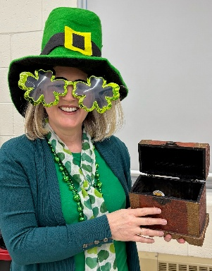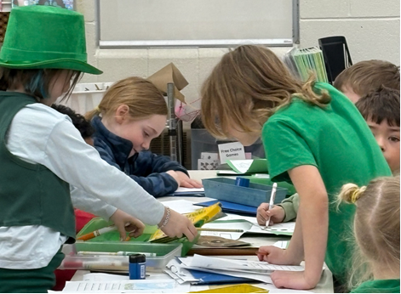
RKT Leprechauns! Sharing treasures, writing ideas and love of Fun!

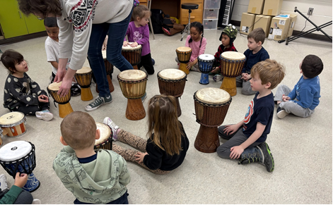
RKT Celebrates Music with New Drums!

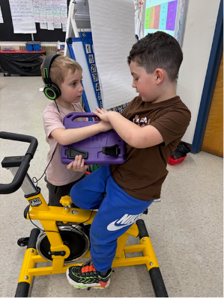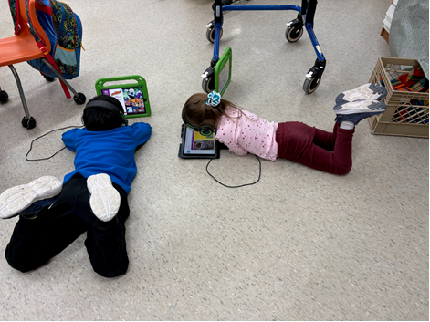
Learning Stations in P/1 – Technology, Math, Language Arts

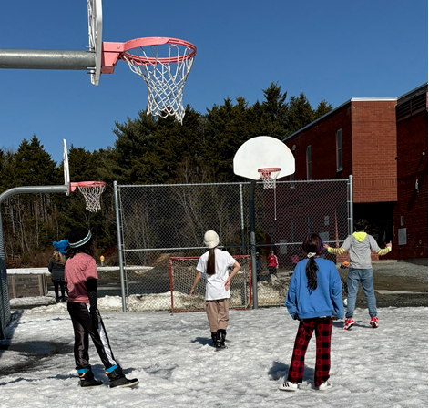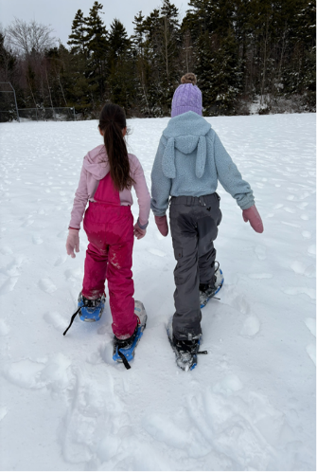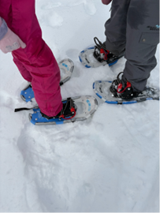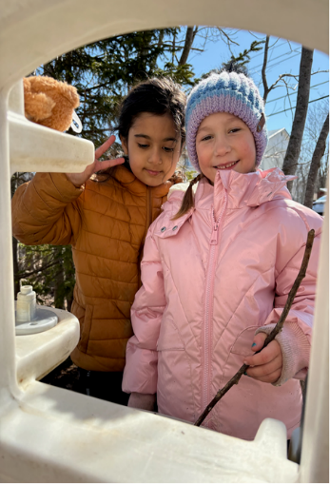
The last sparkling snowy days on the playground. There’s nothing like trying something new with a friend, making the most out of multi-use court, or enjoying the outdoor kitchen’s soup!

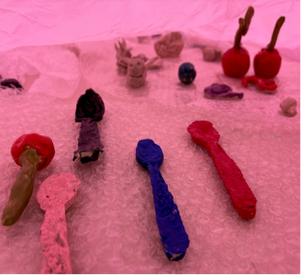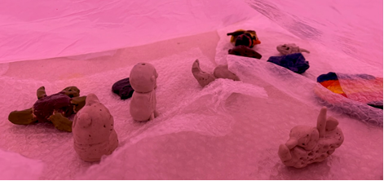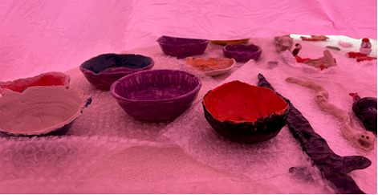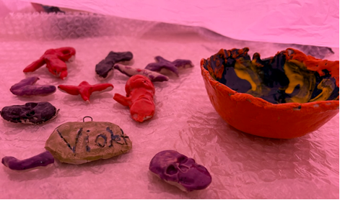

Some amazing 4/5 clay creations from their trips to the Glass Lab!

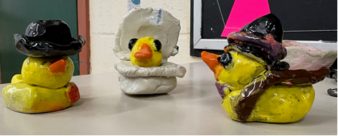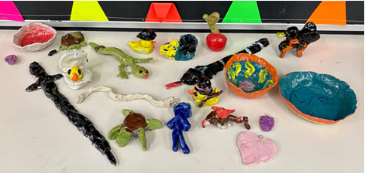

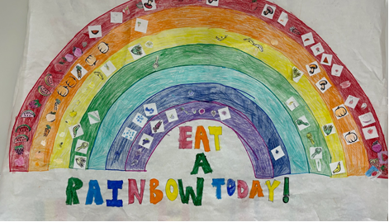

We ended our Nutrition and Healthy Living Month with an afternoon full of activities and food tasting for PP-6. Thanks to our 4/5 students for leading the work!
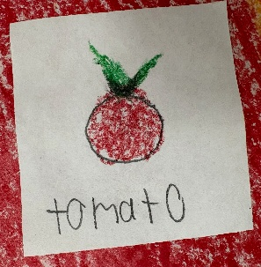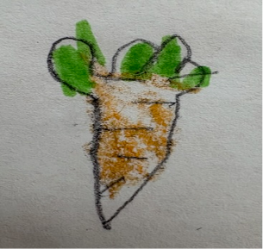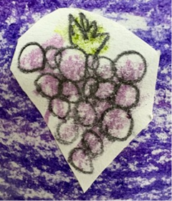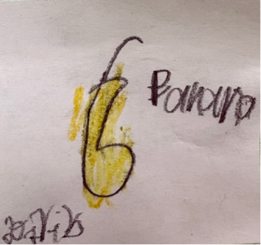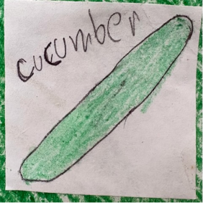
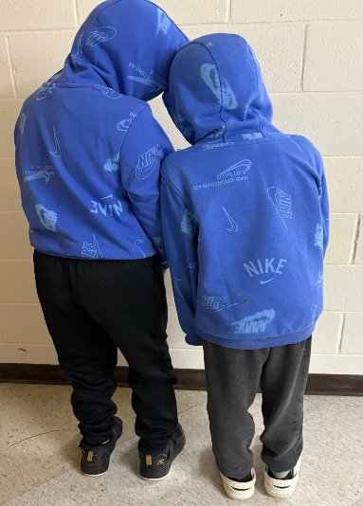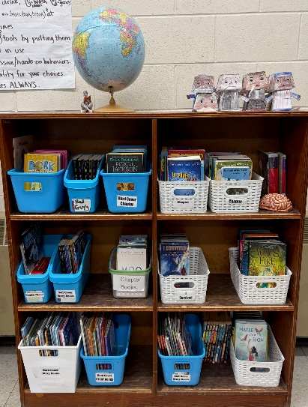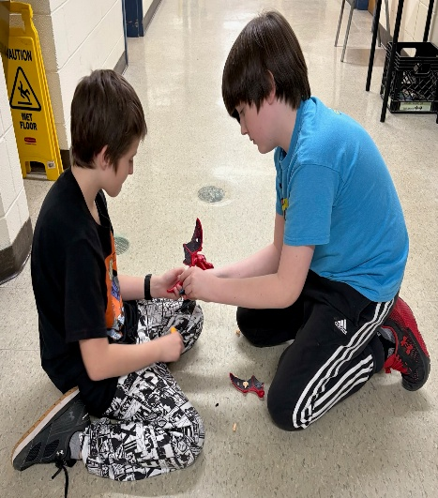
Indoor lunch time fun: organizing our learning spaces, engineering solutions, and

School INFORMATION
Parking Lot Safety
Thank you for your understanding and cooperation in our effort to ensure a safe arrival and departure from school. Please continue to share our parking lot procedures with anyone who may be dropping off/picking up your child(ren). Refer to the map below as an easy visual of the area referenced in the procedures below.
No Cars Permitted – Class Line Up Area

Parking Lot Use Procedures

- Enter the driveway closest to Glenalva Court.
- Remain in the Drop & Go near the bottom of the parking lot (below car spaces) and pull up closest to the Exit before saying goodbye to your child. This allows multiple cars to be in the drop off lane at once and helps prevent blocking the crosswalk and having cars stopped half-way and waiting on the road.
- Exit the driveway directly opposite the school’s main doors.
- The gravel section is to always remain free of cars when students are present. This area is used for class lines and movement during outdoor activities.
- Pulling vehicles away slowing when leaving and watching carefully for our bus and children is always helpful and appreciated!

Halifax Regional Centre for Education (HRCE) INFORMATION
Sharing Questions / Concerns
We want families to feel comfortable reaching out when they have questions or concerns about their child’s education or well-being. In most cases, concerns can be resolved quickly by connecting directly with school staff.
If you do have a concern, here are the steps to follow:
- Start by speaking with your child’s teacher or ECE. They are often best positioned to address questions about your child’s learning or classroom experience.
- If the concern isn’t resolved, contact the school principal to continue the conversation and work toward a solution.
- If you need additional support, HRCE’s Family Navigators are here to help. They can provide guidance and connect families with helpful resources and supports. They can be reached at connect@hrce.ca.
- If the concern still isn’t resolved, a formal review process can be requested and the matter will be looked into by the appropriate HRCE Director.
- The final step is for the concern to be reviewed by the Regional Executive Director.
You can learn more about the process here or by reviewing the Parent/Guardian Concern Policy

Power Outage Information for Families
How decisions are made when a school experiences a power outage.
Our priority is always to keep schools open safely when possible. A power outage does not automatically mean classes are cancelled – even if it happens during the school day. The decision depends on when power is expected to be restored.
Here’s what happens:
- When a school loses power, HRCE's Operations Team contacts Nova Scotia Power to gather available details on the cause and an estimated restoration time.
- Once we have this information, we consider:
- Before school starts: Have buses begun their routes? If so, we wait until students arrive before making a decision. If classes are cancelled, elementary families will be contacted before dismissal.
- During the school day: How close is dismissal? What is the temperature in the building? Does the school rely on power for water or septic systems? These factors, among others, help us decide whether to stay open or close. Often, power returns faster than we could safely send students home.

If classes are cancelled:
- HRCE will notify families by email and text.
- Families of elementary students will also receive a phone call before dismissal.
Deciding to close schools during a power outage is never simple, but safety is always our top priority. We understand that cancellations can be inconvenient, and our goal is to keep students learning in class whenever possible.
More information about school cancellations for any reason can be found here.

Try Carpool Conversations with your Kids
Looking for an easy way to talk with your child about their digital world? Carpool Conversations from Common Sense Media offers short, engaging prompts and mini podcasts designed to spark family discussions about technology, media use, and online behaviour. Many episodes are only a couple of minutes long, perfect for a car ride or while waiting for practice to start. Explore the conversation starters here.

The “Amazing” Adventure Guide
Unplugged Canada encourages families to reclaim childhood by creating more opportunities for outdoor adventure, independence, and real-world responsibility. Research shows that children thrive when they spend more time exploring their neighbourhoods, solving problems with friends, and contributing meaningfully at home and in their communities. Simple steps like walking to a neighbour’s house, biking to a local park, helping plan a family meal or running small errands help kids build confidence, resilience and practical life skills.

Families can support this shift by intentionally creating space for free, unsupervised play and increasing responsibility over time. That might mean designating “no-adult” play zones, encouraging kids to gather in groups of three or more for creative play, or giving them meaningful household roles such as helping with groceries, cooking or caring for pets.

It can feel challenging to step back, but children build independence by practicing it. Families can make it easier by teaming up with other parents in their neighbourhood to create shared boundaries for safe roaming and outdoor play. For more ideas and practical steps, see the full guide: The “Amazing” Adventure Guide from Unplugged Canada.

SCHOOL BASED REMINDERS
Safe Arrival / Student Absences
Our Safe Arrival number is 1-833-582-6940. Please report your child’s absence. If your child is going to be late, please report them as absent and the office will update it when they arrive. Students who arrive after their class line has entered the building must come to the office to check in. Pre-Primary students are to be dropped off at the Pre-Primary door. Please ring the bell on the wall near the PP lineup door and staff will come out to meet you.

Allergy Alerts / Medication
If your child has a severe medical condition and/or requires prescription medication to be taken while at school, please contact the main office for the necessary documentation and procedural information.

Head Lice Reminders
Please make checking for the presence of nits and/or lice part of your family routines. The cold weather does not keep them away.

Water Bottles
Please remember to send a water bottle to school with your child. We have filling stations for them to refill their bottle throughout the day.

Food Donations for Encounter Food Bank
For the month of April, we are collecting canned meat and any other non-perishable donation you would like to share. Supply at the Encounter Food Bank is lower than usual. We continue to collect food items in our school’s main lobby area. Students are encouraged to colour in one of our Caring Heart Squares; let’s see if we can colour a whole heart this month in effort to keep bellies full!

Home and School News
The Glow in The Heart Dance was a great change for laughing together! Thank you volunteers for hosting another fun time for our school community. Your efforts in providing opportunities for our families to make memories together are appreciated! Look for upcoming information about our next Home & School event to be held on Thurs April 23rd – BINGO!

SAC News
Our SAC meeting information can be found on our school website. If your interested to join our committee, please don’t hesitate to let the office know. Our next meeting will be on April 13th from 5:00-6:00 pm.
UPCOMING IMPORTANT DATES

APRIL
Apr 1: Report Cards sent home
Apr 1: Homes & School Meeting 5:30-6:30 pm
Apr 2: Professional Development Day & Parent Teacher Conferences 6:00-8:00 pm – No school for students
Apr 3: Good Friday – Schools Closed
Apr 6: Easter Monday – Schools Closed
Apr 13: SAC Meeting 5:00-6:00 pm
Apr 19-25: National Volunteer Week
Apr 22: Earth Day, Administrative Professionals Day
Apr 23: Home & School Event - BINGO! 6:30-7:30
Apr 29: Professional Development Day – No school for students

MAY
May 4: Grade 6 Band Night – CHDH arrive 5:30 for 6:00 concert
May 6: Home & School Meeting 5:30-6:30
May 11: SAC Meeting 5:00-6:00
May 13-26: Grade 3 Provincial Assessments
May 18: Victoria Day Holiday – Schools Closed
May 21: Spring Concert – evening event

