Robert Kemp Turner Elementary School Newsletter
March 2026
141 Circassion Drive, Dartmouth, NS B2W 4N7 902-464-5205 Safe Arrival 1-833-582-6940

We’re Rockets Soaring to Success!


Dear Family,
Much has happened at RKT of late. We gathered to celebrate the opening ceremony of the Olympics with flags in hand and with a little fame we lit the flame and set light to the fire in our Canadian-Proud hearts.

Our grade six students demonstrated research, communication and presentation skills as they hosted their biography projects. From our youngest to oldest members, our school community was inspired by familiar and new people as they heard and were quizzed on various facts. Well done everyone!

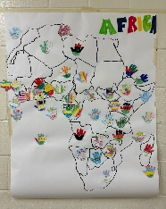 Artwork 4/5 Students 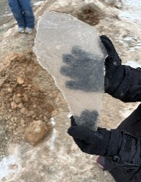 Africa in Ice

Our students participated in numerous African Heritage Month learning opportunities and daily recognition of local African Nova Scotians (ANS) and their cultural contributions; many of whom are connected to RKT! We’d like to highlight the Adams family for their efforts in producing the beautifully designed and informative posters. This year’s theme, “Strength in Unity – Moving Forward with Purpose, Prosperity, Power and Progress,” reminds us of the importance of coming together as a community, learning from one another and moving forward with shared purpose. Our classes will continue learning about ANS, their culture and contributions as the year continues.

Our children in grades 4, 5 and 6 engaged in learning experiences at the Glass Lab and Museum of National History. Thank you to our volunteer chaperones who make these extra-special learning excursions possible.
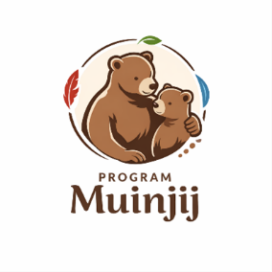
The Muinjij Project has begun at RKT! Participating students enjoyed time with high school student mentors learning new ways to communicate and building community connection while practicing their snowshoeing skills!

Here’s a few of our fun-filled memories!

Snow angels, snow hideaways, snow forts, snowy owls and snow shoeing!!

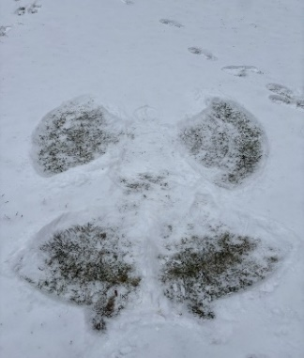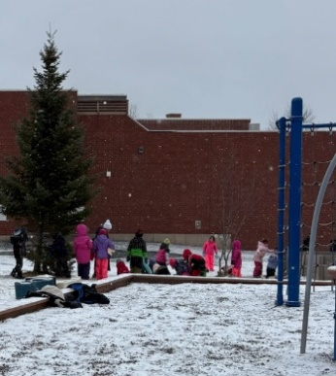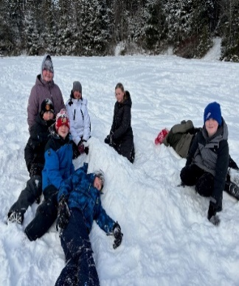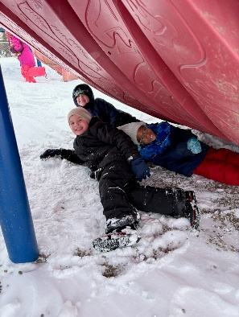

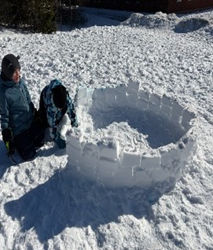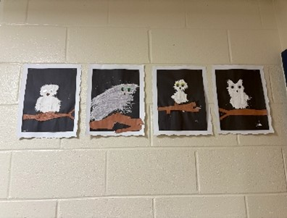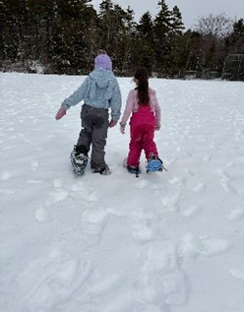

I look forward to what March has to bring us!

Wishing you a wonderful month,
Regan
HRCE & SCHOOL INFORMATION
Parking Lot Safety

Our parking lot use procedures are quite simple. Please share them with anyone who may be dropping off/picking up your child(ren) and refer to the map below as an easy visual of the area referenced in the procedures below.

No Cars Permitted – Class Line Up Area

Parking Lot Use Procedures

- Enter the driveway closest to Glenalva Court.
- Remain in the Drop & Go near the bottom of the parking lot (below car spaces) and pull up closest to the Exit before saying goodbye to your child. This allows multiple cars to be in the drop off lane at once and helps prevent blocking the crosswalk and having cars stopped half-way and waiting on the road.
- Exit the driveway directly opposite the school’s main doors.
- The gravel section is to always remain free of cars when students are present. This area is used for class lines and movement during outdoor activities.
- Pulling vehicles away slowing when leaving and watching carefully for our bus and children is always helpful and appreciated!
Student Enrollment (Registration for Sept 2026)

February was registration month, but it’s not too late to register children in HRCE! Please continue to spread word to families new to the area, letting them know the importance of registering their children. Staffing is directly related to our student enrollment. Please let them know to visit the HRCE website for more information and to enrol their child today through PowerSchool Enrollment!

Have you Moved during this year?

A family move doesn’t automatically mean you must move from our school. Should you wish to continue attending RKT please let the office know and we will support you through the process of applying for ‘Out of Area’. School staffing and class configuration are directly impacted by our registered student numbers. If you wish to continue attending RKT be sure to let us know now rather than worrying if there will be a placement available later.

March is Nutrition Month: Make the Most of the Nova Scotia School Lunch Program


March is celebrated across Canada as Nutrition Month, a perfect opportunity for families to focus on building healthy eating habits together. Nutrition Month allows us to explore sustainable eating patterns, food literacy, and learning about the benefits of balance and variety in everyday meals. By highlighting the connection between nutrition and long-term health, Nutrition Month empowers everyone to build habits that benefit both individuals and the planet.

Use Nutrition Month as a reminder to take advantage of the Nova Scotia School Lunch Program! With nutritious, balanced meals prepared daily, the program ensures students have the energy and focus they need to succeed in the classroom and beyond. The School Lunch Program is designed to provide accessible, affordable, and appealing meals that feature a variety of foods from all food groups, following Canada’s Food Guide. By participating, families can help their children develop lifelong healthy habits while making mornings a little less hectic.
Together, we can make small changes that lead to healthier futures for our families and communities.

March 21 is World Down Syndrome Day

World Down Syndrome Day, celebrated each year on March 21, gives us the chance to recognize those with Down syndrome and the awesome contributions they make to our school communities. It’s an opportunity for families, students, and staff to strengthen inclusion, acceptance, and belonging. By celebrating differences and promoting understanding, our schools help create welcoming environments where every child feels valued and supported.

On this day, many schools encourage students and staff to wear mismatched socks as a colourful symbol of diversity and solidarity. Activities such as assemblies, classroom discussions, and creative projects highlight the abilities of individuals with Down syndrome, fostering empathy and friendship throughout the school. These efforts ensure that everyone has a voice and a place in our communities, reinforcing the importance of respect and kindness.

International Day for the Elimination of Racial Discrimination March 21st


Today we recognize International Day for the Elimination of Racial Discrimination to build awareness, empathy, and respect among students of all backgrounds. The United Nations established this day in 1966 to call for a global commitment to ending racial discrimination in all its forms. By learning about the impacts of discrimination and celebrating diversity, children gain social skills and knowledge to be inclusive both within school and home community. Families are our students first educators and through your continuous conversation valuing equity and the elimination of racism, we will continue our shared goal of a society where racism no longer exist.

Safer Internet Day 2026: Navigating the Internet Safely

As our kids and teens spend more time exploring, creating, and learning online, it’s natural to wonder how we can best support them — especially with emerging technologies like artificial intelligence becoming part of their digital world. On Safer Internet Day 2026, Google shared helpful updates and tools designed to make it easier for families to guide, protect, and empower young people as they navigate the Internet safely. Learn more here.

Responding to Technology-Facilitated Harms Among Young People

Unplugged Canada is hosting a free community event at the Canada Games Centre on Thursday March 5, 2026 at 7 p.m., available both in person and virtually. Join to learn from Dr. Alexa Dodge, Assistant Professor of Criminology at Saint Mary’s University and a leading Canadian researcher on technology-facilitated sexual violence.

This session will explore cyberbullying, the sharing of intimate images, and other online harms youth face, along with research on the support and responses young people need when problems arise online. This presentation will be valuable for any caregiver or adult supporting young people as they navigate the challenges of their digital social lives.

Thursday, March 5, 2026, at 7 p.m.
Canada Games Centre Boardroom - 26 Thomas Raddall Drive, Halifax
Please register for in-person or virtual here.

Open your Home to an International Student!

Have you considered opening your home to an international student? HRCE’s International Services welcomes students from all over the world who would like to attend schools in our region. Hosting a student in your home can be an enriching and rewarding experience. We’re looking for warm and caring families like yours to provide them with a home away from home.

Hosting an international student is a once-in-a-lifetime experience that gives your family the opportunity to bring the world home. For students, it's a way to learn about the Canadian way of life. As a host, your family would be matched with a student who will attend your neighbourhood school and participate in your daily routines.

What you can expect:
- Host families receive a tax-free monthly stipend to help cover hosting expenses ($875)
- Students stay for periods of three to 10 months
- Ongoing support is provided by an experienced Homestay Coordinator
- You will learn about and communicate with your student before their arrival

Learn more here or contact:

HRCE International Services
(902) 464-2000 ext. 2548
hostastudent@hrce.ca

Please share this message with anyone who may be interested.

Thank you! Gracias. Merci. Xie-Xie. Danke. Arigato. Grazie. Obrigado. Kamsa-Hamnida. Kawp-Kun-Ka. Shukran. Teşekkür Ederim.

HRCE International Services

Planning for Inclement Weather

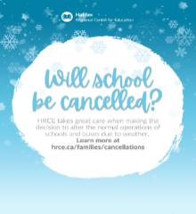
Did you know? HRCE takes great care when making the decision to alter the regular operations of schools and school buses in the event of severe or inclement weather. It is HRCE’s goal to communicate any changes to the regular operations of schools and/or buses as close to 6:00 a.m. as possible.
A 6:00 a.m. announcement could be:
- All schools are delayed in opening by two hours and bus pickups are delayed by two hours; or
- All schools are open, but some or all busses are not operating for the day; or
- Some schools (either individually or by family) are closed for the day; or
- All schools are closed for the day.

If weather deteriorates, or is forecasted to worsen throughout the morning, an 11:00 a.m. announcement could be:
- Bussed students will be picked up two hours earlier than their regular dismissal time at 12:30
- Walking students or students being picked up will be dismissed at their regularly scheduled lunch hour (11:30 am)
How will I find out?
- By email to the addresses in PowerSchool
- By text message, if you have opted in. If you aren’t sure if you have opted-in, text Y to the following number: 978338
- On the HRCE website
- On Instagram
It’s important to always have a plan in place for childcare in the event of any cancellation. Please remember: As a parent or guardian you always have the choice of whether or not to send your child to school. For more information on how HRCE manages during inclement weather, visit hrce.ca/families/cancellations.

Power Outage Information for Families

How decisions are made when a school experiences a power outage.
Our priority is always to keep schools open safely when possible. A power outage does not automatically mean classes are cancelled – even if it happens during the school day. The decision depends on when power is expected to be restored.

Here’s what happens:
- When a school loses power, HRCE's Operations Team contacts Nova Scotia Power to gather available details on the cause and an estimated restoration time.
- Once we have this information, we consider:
- Before school starts: Have buses begun their routes? If so, we wait until students arrive before making a decision. If classes are cancelled, elementary families will be contacted before dismissal.
- During the school day: How close is dismissal? What is the temperature in the building? Does the school rely on power for water or septic systems? These factors, among others, help us decide whether to stay open or close. Often, power returns faster than we could safely send students home.

If classes are cancelled:
- HRCE will notify families by email and text.
- Families of elementary students will also receive a phone call before dismissal.
Deciding to close schools during a power outage is never simple, but safety is always our top priority. We understand that cancellations can be inconvenient, and our goal is to keep students learning in class whenever possible.
More information about school cancellations for any reason can be found here.

SCHOOL BASED REMINDERS

Grade 6 – Student and Parent/Guardian Information Night at Sir Robert Borden Junior High
The Grade 6 Parent/Guardian Information Night at Sir Robert Borden Junior High School will be held on Wednesday March 4th at 6:00pm. This meeting is for parents/guardians and students to attend. It is an opportunity to learn about Sir Robert Borden Junior High and the programs offered including Late French Immersion. Students and families will also have a tour of the building.

Grade 6 – Band Members
On March 30th there will be a Grade 6 Band Night Full Rehearsal at Cole Harbour District High School from 5:00-6:00 pm. This will be preparation for the performance on May 4th. Please refer to the Information letter from Mr. Burzese dated Feb 19/26.

Safe Arrival / Student Absences
Our Safe Arrival number is 1-833-582-6940. Please report your child’s absence. If your child is going to be late, please report them as absent and the office will update it when they arrive. Students who arrive after their class line has entered the building must come to the office to check in. Pre-Primary students are to be dropped off at the Pre-Primary door. Please ring the bell on the wall near the PP lineup door and staff will come out to meet you.

Allergy Alerts / Medication
If your child has a severe medical condition and/or requires prescription medication to be taken while at school, please contact the main office for the necessary documentation and procedural information.

Head Lice Reminders
Please make checking for the presence of nits and/or lice part of your family routines. The cold weather does not keep them away.

Water Bottles
Please remember to send a water bottle to school with your child. We have filling stations for them to refill their bottle throughout the day.

Food Donations for Encounter Food Bank
Thank you for your February Pasta Sauce donations. Some squares remain on our RKT Cares Heart bulletin board. Maybe we’ll see our first fully coloured heart this month! If you are able March’s donation item is cereal.
Speaking of Hearts…Our school will participate this month in the Heart and Stroke Fundraising Campaign. More information will be sent home soon.

Lockdown Practice
Our second practice again was successful. The children and staff set a high standard of invisibility (with words and actions) during these drills. The support and encouragement they give each other during these practices is reassuring.

Home and School Event
Our Spring Home & School event will take place March 26. Despite the snowy Valentine’s plans…don’t put away your dancing shoes! More information will be sent home closer to the date.

SAC News
Our SAC meeting information can be found on our school website. If your interested to join our committee, please don’t hesitate to let the office know.

UPCOMING IMPORTANT DATES

MARCH
Mar 2: SAC meeting 5:00-6:00 pm
Mar 3: Home & School Meeting 5:30-6:30 pm – Note change of date
Mar 4: Sir Robert Borden Jr High Information Session for Grade 6 Students and
Parents/Guardians 6:00 pm (at SRB)
March 8: International Women’s Day
Mar 11: Fluoride Varnish #2
Mar 13: Assessment & Evaluation Day – no school for students
Mar 16-20: March Break – schools closed
March 21: World Down Syndrome Day & International Day for the Elimination of Racial Discrimination
March 26: Home and School Event
Mar 30: Grade 6 Band Night Full Rehearsal at Cole Harbour District High School 5:00-6:00
March 31: International Transgender Day of Visibility

APRIL
Apr 1: Report Cards sent home
Apr 1: Homes & School Meeting 5:30-6:30 pm
Apr 2: Professional Development Day & Parent Teacher Conferences 6:00-8:00 pm
Apr 3: Good Friday – Schools closed
Apr 6: Easter Monday – Schools closed
Apr 13: SAC meeting 5:00-6:00 pm
Apr 23: Home & School Event
Apr 29: Professional Development Day – No school for students

