Robert Kemp Turner Elementary School Newsletter
February 2026
141 Circassion Drive, Dartmouth, NS B2W 4N7 902-464-5205 Safe Arrival 1-833-582-6940

We’re Rockets Soaring to Success!

Dear Family,

The tale of our Nova Scotian winter continues as February brings with it a wintery blast! As we enjoy the snowy weather, we ask you give a little thought to the new year ahead. Do you know a family whose children are ready to come to pre-primary or a family moving into our school area? February is Registration Month and NOW is the time to let them know HRCE registration is open!

February marks African Heritage Month in Nova Scotia. While we recognize and celebrate the contributions of African Nova Scotians on an ongoing basis; February is a dedicated time to appreciate the lives and contributions of African Nova Scotians. This year’s provincial theme is “Strength in Unity- Moving Forward with Purpose, Prosperity, Power and Progress”. Please contact me if you or someone you know would like to share your/their ANS cultural experiences, knowledge, skills and talents with our students and staff.

The African Nova Scotia Flag

Please visit the link below to hear Wendie Wilson tell her story of designing the African Nova Scotia flag. It was unveiled in 2021.
 https://www.youtube.com/watch?v=LQNP7xpeH2k

Red blood and sacrifice Gold cultural richness Green fertility and growth Black the people

Wishing you a wonderful month,
Regan

Ms. R. Clancey
Principal
clanceyr@hrce.ca
HRCE & SCHOOL INFORMATION
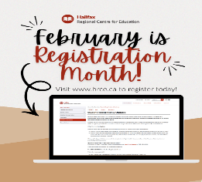
Registration for the 2026-27 school year begins on Monday, February 2. To ensure we have the right staff and supports in place for September, it’s important that we gather enrolment numbers now.
Tip: Before you begin, make sure you have the following documents in electronic form (image, PDF or Word document):
- Proof of identity/age with one of the following: birth certificate, passport, immigration papers, or legal adoption papers if you are new to the HRCE
- Proof of home address with one of the following: a recently dated official government or utility document with your current address that includes your name and date, such as water bill, power bill, internet bill, home fuel bill, a tax receipt, property assessment, a mortgage contract or a residential lease agreement
Visit the HRCE website for more information and to enrol your child today through PowerSchool Enrollment!
Don’t have a child to register? Maybe you know someone who does! Please help us spread the word and pass this information on to friends, neighbours or relatives who will be looking to register for the fall.


African Heritage Month in Nova Scotia is a time to recognize and celebrate the rich history, vibrant culture, and lasting contributions of people of African descent in our province. This year’s theme, “Strength in Unity – Moving Forward with Purpose, Prosperity, Power and Progress,” reminds us of the importance of coming together as a community, learning from one another, and moving forward with shared purpose.
In our schools, African Heritage Month provides meaningful opportunities for students to explore African Nova Scotian histories and experiences, deepen their understanding of our shared past, and reflect on the values of respect, inclusion, and belonging. Through classroom learning, discussions, and activities connected to this year’s theme, students are encouraged to appreciate diversity, build empathy, and recognize the strength that comes from unity. These experiences help foster welcoming school communities and inspire students to contribute positively to a more inclusive and equitable future for all.

Nova Scotia Heritage Day
Nova Scotia Heritage Day is celebrated on Monday, February 16, and provides an opportunity for students and families to learn more about the people, stories, and events that have shaped our province. Each year, Heritage Day honours a notable Nova Scotian, and in 2026 we recognize Joseph William Comeau, an important Acadian poet, writer, and cultural leader.
Joseph William Comeau is remembered for his contributions to Acadian literature and for helping to preserve and promote Acadian language, identity, and culture in Nova Scotia. His work reflected the everyday lives, resilience, and traditions of Acadian communities, and his legacy continues to influence Acadian culture today.
Heritage Day provides us with an opportunity to explore Nova Scotia’s diverse history and to better understand how individuals from different backgrounds have contributed to our shared story. Learning about Joseph William Comeau helps students appreciate the richness of Acadian heritage and the importance of preserving culture, language, and community.

Thriving Offline: How Delaying Smartphones Can Help Kids Flourish
Thriving Offline: How Delaying Smartphones Can Help Kids Flourish, a free community event hosted by Unplugged Canada at St. Margaret’s Bay Elementary, is available both in person and virtually. Designed for caregivers and educators, this session will explore how early smartphone and social media use impacts children’s development and the latest research, practical strategies, safer alternatives, and age-appropriate boundaries to support healthy childhoods.
Join us! Thriving Offline: How Delaying Smartphones Can Help Kids Flourish
- Tuesday, February 24, 2026, at 6:30 p.m.
- St. Margaret’s Bay Elementary - 24 Ridgewood Dr, Head of St Margaret's Bay, NS
- Please register for in-person or virtual here.

Planning for Inclement Weather from HRCE
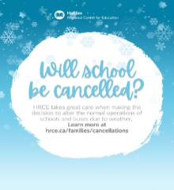
For weather related announcements please note Robert Kemp Turner Elementary is part of the Cole Harbour High Family of Schools. More information about school cancellations for any reason can be found here.
Did you know? HRCE takes great care when making the decision to alter the regular operations of schools and school buses in the event of severe or inclement weather.
It is HRCE’s goal to communicate any changes to the regular operations of schools and/or buses as close to 6:00 a.m. as possible.

A 6:00 a.m. announcement could be:
- All schools are delayed in opening by two hours and bus pickups are delayed by two hours; or
- All schools are open, but some or all busses are not operating for the day; or
- Some schools (either individually or by family) are closed for the day; or
- All schools are closed for the day.

How will I find out?
- By email to the addresses in PowerSchool
- By text message, if you have opted in. If you aren’t sure if you have opted-in, text Y to the following number: 978338
- On the HRCE website
- On Instagram

It’s important to always have a plan in place for childcare in the event of any cancellation. Please remember: As a parent or guardian you always have the choice of whether or not to send your child to school. For more information on how HRCE manages during inclement weather, visit hrce.ca/families/cancellations.
Wind Chill Safety
Several factors are considered before taking students outside. These factors include student dress and weather protection, duration spent outside, movement possibility for students, wind exposure, presence of ice and sunshine are all taken into consideration when making daily decisions. Guidelines are followed as part of our HRCE procedures when making these decisions. Each school playground and its weather condition is unique. Therefore, decisions for outside/inside recreation periods are made on the given day and for each recreation period following ‘real-time’ condition checks.

Power Outage Information for Families
How decisions are made when a school experiences a power outage.
Our priority is always to keep schools open safely when possible. A power outage does not automatically mean classes are cancelled – even if it happens during the school day. The decision depends on when power is expected to be restored.
Here’s what happens:
- When a school loses power, HRCE's Operations Team contacts Nova Scotia Power to gather available details on the cause and an estimated restoration time.
- Once we have this information, we consider:
- Before school starts: Have buses begun their routes? If so, we wait until students arrive before making a decision. If classes are cancelled, elementary families will be contacted before dismissal.
- During the school day: How close is dismissal? What is the temperature in the building? Does the school rely on power for water or septic systems? These factors, among others, help us decide whether to stay open or close. Often, power returns faster than we could safely send students home.

If classes are cancelled:
- HRCE will notify families by email and text.
- Families of elementary students will also receive a phone call before dismissal.
Deciding to close schools during a power outage is never simple, but safety is always our top priority. We understand that cancellations can be inconvenient, and our goal is to keep students learning in class whenever possible.
More information about school cancellations for any reason can be found here.

Two Truths & AI
Two Truths & AI is a free, interactive activity from Common Sense Education that helps students learn how to tell the difference between real and AI-generated content. Through guided examples, students practice asking good questions and thinking critically about what they see online. This resource can also be a helpful way for parents and caregivers to build their own understanding of AI and media literacy alongside their children. Learn more here.

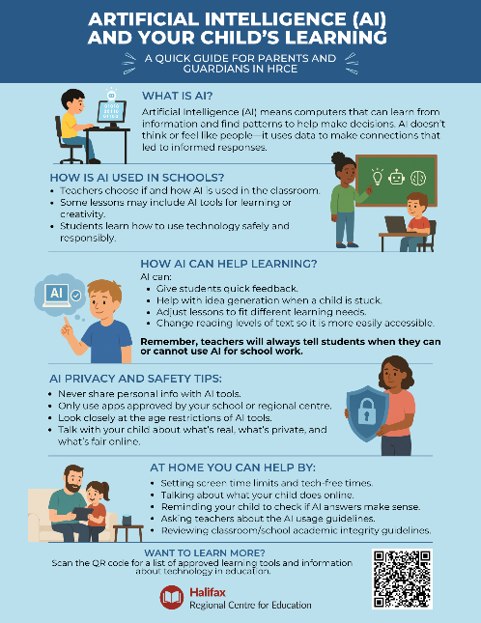

SCHOOL BASED REMINDERS

Safe Arrival / Student Absences
Our Safe Arrival number is 1-833-582-6940. When your child arrives late, the office will update their attendance. Students who arrive after their class line has entered the building must come to the office for a late slip. Pre-Primary students are to be dropped off at the Pre-Primary door. Please ring the bell on the wall near the PP lineup door and staff will come out to meet you.

Allergy Alerts / Medication
If your child has a severe medical condition and/or requires prescription medication to be taken while at school, please contact the main office for the necessary documentation and procedural information.

Head Lice Reminders
Please make checking for the presence of nits and/or lice part of your family routines. The cold weather does not keep them away.

Water Bottles
Please remember to send a water bottle to school with your child. We have filling stations for them to refill their bottle throughout the day.

WHAT’S HAPPENING AT RKT


Food Donations for Encounter Food Bank

This month the Encounter Food Bank food drive item is Pasta Sauce. If you are able, donations will be collected at the main lobby under the RKT Cares Heart bulletin board. Let’s see if we can fill up our heart this month!

Lockdown Practice
We will be having our second Lockdown Practice as part of our routine safety drills next week. More information regarding this will be sent home in a separate communication soon.

Home and School Event
There will be a Valentine’s Day Dance on Feb 12th from 6:30-7:30 hosted by the H&S Committee. If you are available to help with this event, please contact rkthomeandschool@gmail.com.

UPCOMING IMPORTANT DATES
FEBRUARY
Feb 4: Home and School Meeting 5:30-6:30
Feb 8-12: Lockdown Practice sometime this week
Feb 12: Valentines Day Dance 6:30-7:30
Feb 16: Heritage Day – no school
February 17: Lunar New Year

MARCH
Mar 2: SAC meeting 5:00-6:00
Mar 4: Home & School Meeting 5:30-6:30
Mar 11: Fluoride Varnish #2
Mar 13: Assessment & Evaluation Day – no school for students
Mar 16-20: March Break – schools closed

