Robert Kemp Turner Elementary School Newsletter
January 2026
141 Circassion Drive, Dartmouth, NS B2W 4N7 902-464-5205 Safe Arrival 1-833-582-6940

We’re Rockets Soaring to Success!


Dear Family,

Winter weather welcomes us back together in January! This month’s newsletter contains much HRCE pieces of information including our cold weather protocols and procedures. For weather related announcements, please note RKT’s Family of Schools is Cole Harbour High School. Nova Scotia weather is known to change quickly!

We kindly ask that you ensure your child comes to school with a water bottle (filled), a change of clothes (including extra socks), layers of clothes, and weather forecasted appropriate items (ie. jacket, snowpants, mittens/gloves, hat, scarf, boots). This helps everyone and prevents calls home for new clothing when the playgrounds are wet or snowy. If we can help with providing additional clothing for your child, please let us know.

Before we head too far into our new year, we extend appreciation to all families who attended our Holiday Concerts. We know extended family and friends took time from work and travelled from far and we thank YOU! Having an audience for work well done is always more fun! Again, thank you to Mr. Burzese and Staff for their dedication, volunteer time and attention in supporting our students.

A special acknowledgement goes to our amazing Home & School volunteers who hosted a wonderfully festive Holiday Shoppe for students and staff again this year. The care the volunteers shared with children as they shopped for the perfect present was heartwarming! And…thank you RKT Community for the many donations of items and wrapping supplies. Your sharing made special moments possible for our children!

Today’s sharing of smiles and holiday tales were a few reminders of why we’re happy to be back together!

Wishing you and your family the best 2026 has to offer!
Regan

Ms R. Clancey
Principal
clanceyr@hrce.ca

IMPORTANT GENERAL INFORMATION

Inclement Weather and School Closures
Robert Kemp Turner Elementary is part of the Cole Harbour High Family of Schools

Power Outage Information for Families from HRCE
As we move into the winter months, we want to share how decisions are made when a school experiences a power outage. Our priority is always to keep schools open safely when possible. A power outage does not automatically mean classes are cancelled – even if it happens during the school day. The decision depends on when power is expected to be restored.

Here’s what happens:
- When a school loses power, HRCE's Operations Team contacts Nova Scotia Power to gather available details on the cause and an estimated restoration time.
- Once we have this information, we consider:
- Before school starts: Have buses begun their routes? If so, we wait until students arrive before making a decision. If classes are cancelled, elementary families will be contacted before dismissal.
- During the school day: How close is dismissal? What is the temperature in the building? Does the school rely on power for water or septic systems? These factors, among others, help us decide whether to stay open or close. Often, power returns faster than we could safely send students home.

If classes are cancelled:
- HRCE will notify families by email and text.
- Families of elementary students will also receive a phone call before dismissal.
Deciding to close schools during a power outage is never simple, but safety is always our top priority. We understand that cancellations can be inconvenient, and our goal is to keep students learning in class whenever possible.
More information about school cancellations for any reason can be found here.

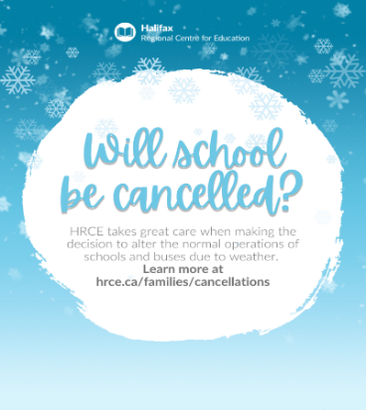
Planning for Inclement Weather from HRCE
Did you know? HRCE takes great care when making the decision to alter the regular operations of schools and school buses in the event of severe or inclement weather.
It is HRCE’s goal to communicate any changes to the regular operations of schools and/or buses as close to 6:00 a.m. as possible.
A 6:00 a.m. announcement could be:

- All schools are delayed in opening by two hours and bus pickups are delayed by two hours; or
- All schools are open, but some or all busses are not operating for the day; or
- Some schools (either individually or by family) are closed for the day; or
- All schools are closed for the day.

If weather deteriorates, or is forecasted to worsen throughout the morning, an 11:00 a.m. announcement could be:
- Bussed students will be picked up two hours earlier than their regular dismissal time; and
- Walking students will be dismissed at their regularly scheduled lunch hour.
How will I find out?
- By email to the addresses in PowerSchool
- By text message, if you have opted-in. If you aren’t sure if you have opted-in, text Y to the following number: 978338
- On the HRCE website
- On Instagram
It’s important to always have a plan in place for childcare in the event of any cancellation. Please remember: As a parent or guardian you always have the choice of whether or not to send your child to school.
For more information on how HRCE manages during inclement weather, visit hrce.ca/families/cancellations.

Wind Chill Safety
Student safety is the number one priority. Several factors are considered before taking students outside. These factors include student dress and weather protection, duration spent outside, movement possibility for students, wind exposure, presence of ice and sunshine are all taken into consideration when making daily decisions. Guidelines are followed as part of our HRCE procedures when making these decisions. Each school playground and its weather condition is unique. Therefore, decisions for outside/inside recreation periods are made on the given day and for each recreation period following ‘real-time’ condition checks.

Learn About the Influenza Vaccine
On behalf of the Nova Scotia Department of Health and Wellness.
Fast Facts about the Flu Vaccine
- Influenza (the flu) is virus that peaks in transmission in the fall and winter months
- Most people are mildly ill when they contract the flu but sometimes the flu can be serious and require admission to the hospital
- Children under 6 years are at the highest risk of serious complications from the flu
- The flu and RSV can occur at the same time making children more at risk of needing hospitalization
- The flu vaccine is recommended yearly for children 6 months and older to protect against serious complications of the flu
For more information, click here.

Learning more about the Student Attendance and Engagement Policy
Did you know? The Student Attendance and Engagement Policy guides our approach to attendance and is in place to support all students.
The policy states that regular, punctual attendance supports academic success, responsibility, and preparation for the future.
Ensuring regular attendance is a joint effort between students, families and schools. As a parent/guardian, you play an important role by monitoring attendance, communicating with the school when your child is absent, and supporting your child’s regular attendance.
What Should You Know?
Communication about absences
    - Schools will monitor attendance and lateness.
    - All absences must be communicated to the school, following the school’s procedure.
    - If absenteeism or lateness reaches 10% of class time, the school will begin to engage more actively with the student and family.
    - If it goes beyond 15%, more targeted supports may be used (counselling, referrals, community supports).

Online Platform Risks From Unplugged Canada
Sharing on behalf of Unplugged Canada
Many digital platforms today, including social media, online gaming and AI chat tools, are designed to keep kids scrolling and engaged, often exposing them to addictive features, adult content, and interactions they may not be developmentally ready to handle.
Below is a resource that outlines some of the most common social media, gaming, and AI chat platforms, helping families better understand the risks, start meaningful conversations at home, and consider delaying smartphones and access to these apps until kids are more developmentally ready. You can access the full resource here.
Unplugged Canada is a parent-led, national movement advocating for healthier childhoods by delaying smartphones and social media until kids are more developmentally ready. Join thousands of Canadian families choosing to delay by taking the Unplugged Canada Pledge at unpluggedcanada.com/sign-pledge.

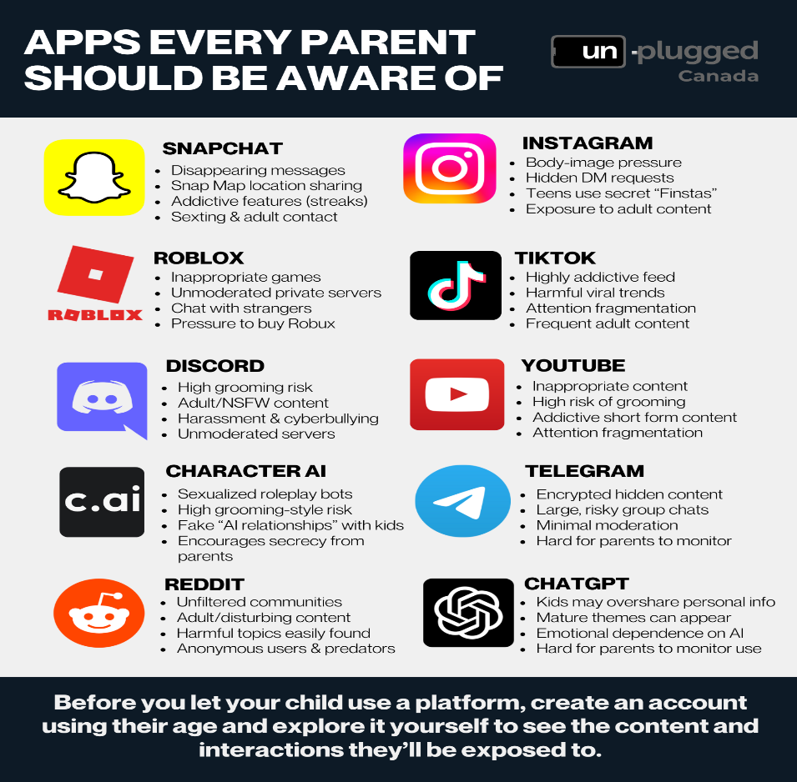

New Educational Technology Resource for Families

HRCE is excited to share a new online resource designed to help families understand how technology supports student learning. This page provides an overview of how tools like Chromebooks and Google for Education are used in classrooms, what provincially approved online platforms students may access, and how student privacy is protected. You’ll also find information about Nova Scotia’s guidance on the provincial cell phone expectations, tips for supporting online safety and digital citizenship at home, and an introduction to how students are learning about artificial intelligence in a thoughtful and responsible way. It also includes answers to common questions about screen time, passwords, communication during the school day, and more. You can find the webpage here.

AI and Your Child's Learning
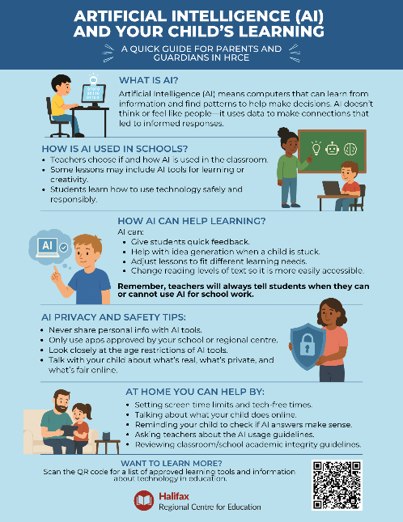

HRCE teachers and staff are introducing students to artificial intelligence (AI) in safe and meaningful ways that build awareness, creativity, and critical thinking. Together, we can help our learners understand how to use AI responsibly and confidently in their education and everyday lives. This informational sheet provides you with starting points for conversations about AI and learning. Click here to download the document. PLEASE NOTE: You will need to download and attach the document yourself to your family correspondence. You can not simply copy and paste this link.

SCHOOL BASED REMINDERS

Safe Arrival / Student Absences
Our Safe Arrival number is 1-833-582-6940. When your child arrives late, the office will update their attendance. Students who arrive after their class line has entered the building must come to the office for a late slip. Pre-Primary students are to be dropped off at the Pre-Primary door. Please ring the bell on the wall near the PP lineup door and staff will come out to meet you.

Thank you for following our ‘Kiss and Go’ drop off in the mornings. It takes all of us to keep everyone safe; thank you for doing your part!

Allergy Alerts / Medication
If your child has a severe medical condition and/or requires prescription medication to be taken while at school, please contact the main office for the necessary documentation and procedural information.

Head Lice Reminders
Please make checking for the presence of nits and/or lice part of your family routines. The cold weather does not keep them away

WHAT’S HAPPENING AT RKT

Home and School Committee and School Advisory Council
Thank you to those parents and guardians who wrote thoughts on our ‘Wall Town Hall’ during our Parent Teacher Conference sessions. We are working with your thoughts and want to hear more. Joining in on one of these groups is a great chance to share them and learn about what is happening at our school. Please contact us if you or someone you know is interested.

Community Health Team Caregiver Series
Our Schools Plus Facilitator, Samantha Davis, is working with the Community Health Team to host Caregiver Connect Series for our family of schools. RKT will be hosting the next session on January 28th at 6:30-8:00 pm. The topic is Parent Wellness Behaviour 101. This will be an opportunity to discuss and learn skills to respond effectively to kids’ behaviour and keep things calm at home. Additional information about registering will be coming soon!

Food Donations for Encounter Food Bank
This month the Encounter Food Bank donation item is ______________. If you are able, donations will be collected at the main lobby under the RKT Cares Heart bulletin board. Students are invited to colour in a heart square for every item donated; let’s see if we can fill up our heart!
UPCOMING IMPORTANT DATES
JANUARY
Jan 5: First day of school for 2026
Jan 7: Home and School Meeting 5:30-6:30
Jan 19: School Advisory Council SAC Meeting 5:00-6:00
Jan 27: International Holocaust Remembrance Day & Family Literacy Day
Jan 28: Caregiver Connect Series Session (‘Behaviour 101’) hosted by SchoolsPlus and Community Health Team at RKT at 6:30-8:00pm

FEBRUARY
Feb 4: Home and School Meeting 5:30-6:30
Feb 8-12: Lockdown Practice sometime this week
Feb 12: Valentines Day Dance 6:00-7:00
Feb 16: Heritage Day – no school

